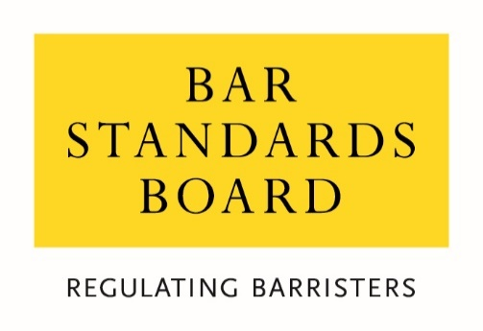

Consultation response form

Consultation on the proposed BSB strategy for
2022-23 to 2025-26

October 2021

Question 1: With reference to our regulatory objectives do you agree that those set out in the consultation document are the main risks and opportunities facing barristers and the market for barristers’ services: is there anything you would add or omit?

Question 2: Do you agree with the vision for the BSB and the Bar set out in the document: is there anything you would add or omit?

Question 3: Do you agree that those set out in the document should be the BSB’s priorities: is there anything you would add or omit and how would you rank these priorities?

Question 4: Do you agree that those listed in the document are the key areas where the BSB needs to develop as an organisation?

Question 5: Are there any particular areas on which we might collaborate with you, or with others, to further the priorities set out in our consultation document?

Question 6: Have you identified any risks or opportunities in relation to promoting equality, diversity and inclusion for the profession or the public?

Are you a:

- Barrister
- Law Student
- Education and training provider
- Legal consumer / member of the public
- Representative of legal consumers
- Other legal professional
- Legal services representative body
- Other (please specify)

Are you responding in an individual capacity or as a representative of your organisation?

- Individual response
- Organisational response

Please give your name or the name of your organisation if you do not wish your response to be anonymous:

Equality Monitoring Information
We seek to monitor individual respondents to help us to understand the extent to which our consultations are being responded to by people from different backgrounds and so that we can understand where we need to do more to target the views of people from particular backgrounds. These questions are entirely optional and will be treated in the strictest confidence and in accordance with our privacy policy.
If you are responding to this consultation as an individual, please complete the following questions:
- What is your age?
- Under 25
- 25-34
- 35-44
- 45-54
- 55-64
- Over 65
- Prefer not to say

- What is your sex?
- Male
- Female
- Prefer not to say

- Is your gender identity the same as the sex with which you were assigned at birth?
- Yes
- No
- Prefer not to say

- What best describes your gender?
- Female
- Male
- Prefer not to say
- I describe myself as:

- Do you consider yourself to have a disability?
- Yes
- No
- Prefer not to say

- Is your ability to perform day-to-day activities limited because of a physical or mental disability, condition or illness, which has lasted or is expected to last for at least 12 months?
- Yes, a lot
- Yes, a little
- Not at all
- Prefer not to say

- What is your ethnic group?
- White – ﻿English/Welsh/Scottish/Northern Irish/﻿British
- White – Irish
- White – Gypsy or Irish Traveller
- White – Roma
- White – I use a different term to describe my White ethnic background
- Asian/Asian British – Bangladeshi
- Asian/Asian British – Chinese
- Asian/Asian British – Indian
- Asian/Asian British – I use a different term to describe my Asian ethnic background
- Black/Black British – African
- Black/Black British – Caribbean
- Black/Black British – I use a different term to describe my Black ethnic background
- Mixed/Multiple Ethnic Background – White and Asian
- Mixed/Multiple Ethnic Background – White and Black African
- Mixed/Multiple Ethnic Background – White and Black Caribbean
- Mixed/Multiple Ethnic Background – White and Chinese
- Multiple Ethnic Background - I use a different term to describe my Mixed/Multiple ethnic background
- Arab
- I use a different term to describe my ethnicity, which does not fall under “White”, “Asian”, “Black” or “Mixed/Multiple Ethnic Background”
- Prefer not to say

- What is your religion or belief?
- No religion
- Buddhist
- Christian
- Hindu
- Jewish
- Muslim
- Sikh
- Prefer not to say
- I have a different religion or belief

- Which of the following best describes your sexual orientation?
- Heterosexual
- Gay or Lesbian
- Bisexual
- Prefer not to say
- I use a different term

- Did you mainly attend a state or fee-paying school between the ages of 11 – 18?
- UK State school
- UK fee-paying school
- School outside UK
- Prefer not to say

- If you finished school after 1980, were you eligible for Free School Meals at any point during your school years?
- Yes
- No
- Not applicable
- Don’t know

- If you went to university (to study a BA, BSc or higher), had either (or both) of your parents or carers attended university by the time you were 18?
- Yes
- No
- Don’t know
- I didn’t attend university
- Prefer not to say

- Are you a primary carer for a child or children under 18?
- Yes
- No
- Prefer not to say

- Do you look after, or give any help or support to family members, friends, neighbours or others because of either: long-term physical or mental ill-health/disability or problems relating to old age? (Do not count anything you do as part of paid employment).
- No
- Yes, 1-19 hours a week
- Yes, 20-49 hours a week
- Yes, 50 or more hours a week
- Prefer not to say

