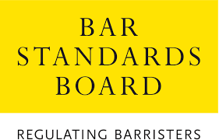

Registration form
Webinar about the new centralised assessment in Professional Ethics to be taken during pupillage by pupils who commenced their Bar training from 2020 onwards.

To register to attend this webinar, please provide your name, organisation and role below.
The webinar is your chance to find out more about the new centralised assessment in Professional Ethics to be taken by pupils during their pupillage. All pupils who started their Bar Training in 2020 or 2021, or who completed the Bar Transfer Test after August 2021, must take and pass this new exam before they can complete their pupillage.
BPTC graduates are not required to do so, as they have already passed a centralised exam in Ethics, and some transferring qualified lawyers may have been given a waiver by us so may be exempt.

Name:

Email address:

Organisation:

Role within your organisation:

