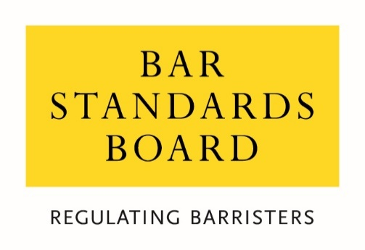

Barristers supervising immigration advisers

Rule change consultation

October 2019
- This paper seeks your views on a possible rule change to the Bar Standards Board’s (BSB) Handbook, which sets out the regulatory obligations on barristers.

- The rule change would prohibit barristers from supervising immigration advisers who have received certain sanctions from the Office of the Immigration Services Commissioner (OISC – the regulator of immigration advice and services), an approved legal services regulator, or a designated professional body.

Background

- Section 84(2)(e) of the Immigration and Asylum Act 1999 (‘the Act’) enables barristers to supervise unregulated immigration advisers. However, OISC have concerns that people who should not be giving immigration advice because they have been subject to the sanctions below could nonetheless be supervised by barristers under the legislation:

- Cancelled or refused registration; or

- Disqualified in accordance with paragraph 4 of Schedule 6 to the Immigration and Asylum Act 1999 (as amended) (IAA 1999); or

- Prohibited or suspended by the First-tier Tribunal (Immigration Services).

- The fact that advisers who are subject to the above sanctions are still able to provide immigration services to clients when supervised by a barrister has the unintended result of undermining OISC’s regulatory regime. This could result in harm to immigration consumers, and potentially undermine the trust and confidence which the public places in barristers (and the wider legal and immigration system).

- To ensure consistency and to prevent the regimes of approved legal regulators or designated professional bodies from being undermined, we propose to prohibit barristers from supervising an individual who has been subject to one of the sanctions listed in paragraph 3 above, or who has been struck off or disbarred or is currently suspended by their approved regulator or designated professional body.

Proposed rule

- We propose that the following wording should be included within the BSB Handbook under the ‘associations with others’ rules:

rC85A You must not act as a supervisor of an immigration adviser for the purposes of section 84(2) of the Immigration and Asylum Act 1999 (as amended) (IAA 1999) where the Office of the Immigration Services Commissioner has refused or cancelled the adviser’s registration, or where the adviser is:

- disqualified in accordance with paragraph 4 of Schedule 6 to the IAA 1999; or

- prohibited or suspended by the First-tier Tribunal (Immigration Services); or

- permanently prohibited from practising by an approved regulator, or a designated professional body under the Immigration and Asylum Act 1999, pursuant to its powers as such, and removed from the relevant register; or

- currently suspended from practising by an approved regulator, or a designated professional body under the Immigration and Asylum Act 1999, pursuant to its powers as such.

Question 1: Do you agree that we should prohibit barristers from supervising immigration advisers in the circumstances described above and with our proposed wording of the prohibition?

- Barristers are already required to notify us if they are currently supervising an immigration adviser under our ‘associations with others’ rules. We intend to formalise this process by requiring barristers to notify us during the annual Authorisation to Practise (AtP) process, and at any other time during the year (via MyBar, the online portal) if they are currently supervising an immigration adviser or intend to do so within the next 12 months. No further rules are necessary as this new process is adequately captured within our rules on ‘associations with others’ and issuing of practising certificates.

Other issues and proposals

- We currently have guidance for barristers who are supervising immigration advisers which reminds them of their obligations under our Handbook. It also provides an overview of what we expect from supervisory arrangements. However, we propose to set out in more detail what we would expect good supervision to look like and how to comply with any new rules. This is likely to be via case studies and clearer guidelines on our expectations. Barristers will be signposted to this guidance in our Handbook.

Question 2: Do you have examples of good supervision arrangements which could be used to inform our guidance and case studies?

Let us know your thoughts

- Please let us know what you think by Friday 8 November 2019 via one of the methods below:

Email: professionalstandards@barstandardsboard.org.uk

Telephone: 020 7611 1444

Address: Professional Standards Team
The Bar Standards Board
289-293 High Holborn
London
WC1V 7HZ

Section 20 of the Legal Services Act 2007
Section 86 of Immigration & Asylum Act 1999
rC79 onwards in the BSB Handbook. An association means where: (a) BSB authorised individuals are practising as a chambers; or (b) BSB authorised persons are sharing premises and/or costs and/or using a common vehicle for obtaining or distributing work with any person other than a BSB regulated person, in a manner which does not require the association to be authorised as an entity under the Legal Services Act 2007
rC80 of the BSB Handbook
rS48 and rS69
This signposting guidance will be included below any new rules within the associations section.

