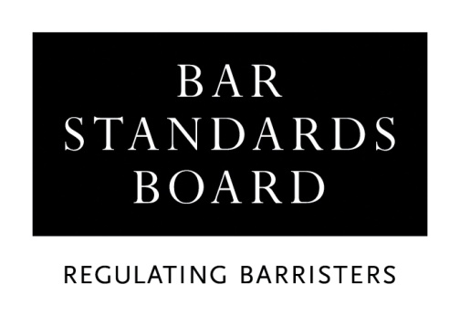

APPLICATION FOR EARLY COMMENCEMENT OF THE VOCATIONAL COMPONENT OF BAR TRAINING (COVID-19)

Before completing and submitting this form, you must read the accompanying criteria and guidelines document in full, together with the Checklist.

This form must be completed in type or BLOCK CAPITALS.

Full name:
(Please underline family name/surname)

Title: Miss/Mr/Mrs/Ms (Delete as appropriate)

Address:

Daytime telephone no. | Code: | No:
email address:
(Please print clearly)
Date of birth:
Inn of court (if known):
I have been offered a place on a vocational component Bar Training Course (Y/N):

Year:

Institution:

Full-time / part-time / distance learning (Delete as appropriate)

You must ensure that you complete the correct section, ie: GDL or UK Law Degree. Failure to do so will result in your application being delayed.

If you are completing the academic component of training for the Bar by means of a Common Professional Examination/Graduate Diploma in Law course, you must give details here. All dates must be entered in full: ie, 00/00/00.

Institution and Course Title:
Subjects passed:
Subject(s) remaining:
Date(s) final result(s) will be known:
Predicted overall result:
Mode of study (delete as appropriate) | Full-time / Part-time / Distance Learning

If you are completing the academic component of training for the Bar by means of a UK Law Degree, you must give details here. All dates must be entered in full: ie, 00/00/00.

Institution and Course Title:
Subjects passed:
Subject(s) remaining:
Date(s) final result(s) will be known:
Predicted final degree classification:
Mode of study (delete as appropriate) | Full-time / Part-time / Distance Learning

OTHER INFORMATION
Please set out below any further information that you consider to be relevant to your application:

DECLARATION
I declare that:
- I have read the criteria and guidelines;
- The information I have given in this application is complete and true;
- Any supporting evidence that I have supplied with this application that refers to third parties has been suitably redacted so as to preserve the anonymity of third parties;
- I am submitting this application with the intention of undertaking the academic component of training for the Bar, and;
- I have read the Bar Standards Board’s Privacy Statement and understand how my data will be handled.

Signature:

Name:

Date:

You must now refer to the Checklist.

Checklist

A student is not eligible to commence the vocational component of Bar training unless and until that student has fully and satisfactorily completed the academic component or been granted a waiver to commence a vocational component Bar Training Course by the Bar Standards Board. To ensure that this requirement is met, applicants must allow at least six weeks for the processing of this application.

Before returning this form, you must ensure that you have:

- Provided a certified copy (please see notes on completing application form) of the relevant documentation if, for any reason, you have changed your family name/surname since you commenced your academic component studies;

- Enclosed evidence of your academic component qualifications to date which must be in the form of official transcript(s) for all academic component qualifications listed on this application. You must refer to the transcript format requirements under the appropriate section of the guidance notes before submitting transcripts. If necessary, it is acceptable for you to request that these documents are sent directly to the Bar Standards Board (BSB) by the awarding institution; however, the BSB will not contact third parties for this, or any other purpose;

- Completed and dated the application form. The form may be submitted in hard copy or by email;

- Provided and clearly labelled any relevant supporting evidence in the format specified;

- Completed the Equal Opportunities Monitoring form, and;

Unless specifically requested by ticking one of the boxes below, any documents provided in support of an application will be destroyed through the Bar Standards Board’s (BSB) confidential waste procedures.

□ I wish for my documents to be returned in the pre-paid self-addressed envelope provided by me

□ I wish for my documents to be returned by ordinary post

This form must now be returned to:

Authorisations Team
Regulatory Operations Department
The Bar Standards Board
289-293 High Holborn
London
WC1V 7HZ

Telephone: (020) 7611 1444
Email: authorisations@barstandardsboard.org.uk

 | 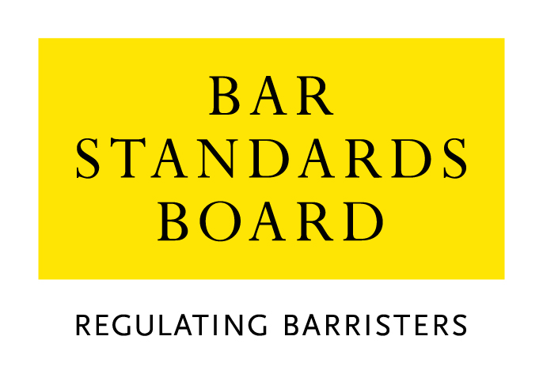

Equality & Diversity Monitoring Form

Diversity data gathered from this form will be anonymised and used to inform Bar Council and Bar Standards Board (BSB) policy aimed at widening access to the profession and improving diversity. It will assist the Bar Council and BSB in meeting our statutory duties under the Equality Act 2010 and will inform our wider equality and diversity strategy.

Your diversity data will be treated as confidential and stored securely according to the Bar Council’s Privacy policy. It will not be published in a way which might identify any individual. The raw data will be kept only for monitoring purposes.

Question formats are based on LSB approved monitoring questions.

Provision of diversity information is not compulsory however we strongly encourage you to help us by completing this form.

Please answer each question in turn by choosing one option only, unless otherwise indicated. If you do not wish to answer the question please choose the option ‘Prefer not to say’ rather than leaving the question blank.

1. Age

From the list of age bands below, please indicate the category that includes your current age in years:

16 - 24
25 - 34
35 - 44
45 - 54
55 - 64
65+
Prefer not to say

2. Gender

What is your gender?

Male
Female
Prefer not to say

3. Disability

The Equality Act 2010 generally defines a disabled person as someone who has a mental or physical impairment that has a substantial and long-term adverse effect on the person’s ability to carry out normal day-to-day activities.

(a) Do you consider yourself to have a disability according to the definition in the
Equality Act?

Yes
No
Prefer not to say

(b) Are your day-to-day activities limited because of a health problem or disability which has lasted, or is expected to last, at least 12 months?

Yes, limited a lot
Yes, limited a little
No
Prefer not to say

4. Ethnic group

What is your ethnic group?

Asian / Asian British

Bangladeshi
Chinese
Indian
Pakistani
Any other Asian background (write in)

Black / African / Caribbean / Black British

African
Caribbean
Any other Black / Caribbean / Black British (write in)

Mixed / multiple ethnic groups

White and Asian
White and Black African
White and Black Caribbean
White and Chinese
Any other Mixed / multiple ethnic background (write in)

White

British / English / Welsh / Northern Irish / Scottish
Irish
Gypsy or Irish Traveller
Any other White background (write in)

Other ethnic group

Arab
Any other ethnic group (write in)

Prefer not to say

Prefer not to say
5. Religion or belief

What is your religion or belief?

No religion or belief
Buddhist
Christian (all denominations)
Hindu
Jewish
Muslim
Sikh
Any other religion (write in)
Prefer not to say

6. Sexual orientation

What is your sexual orientation?

Bisexual
Gay man
Gay woman/lesbian
Heterosexual/straight
Other
Prefer not to say

7. Socio-economic background

(a) If you went to University (to study a BA, BSc course or higher), were you part of the first generation of your family to do so?

Yes
No
Did not attend University
Prefer not to say

(b) Did you mainly attend a state or fee paying school between the ages 11 – 18?

UK State School
UK Independent/Fee-paying School
Attended school outside the UK
Prefer not to say

8. Caring responsibilities

(a) Are you a primary carer for a child or children under 18?

Yes
No
Prefer not to say

(b) Do you look after, or give any help or support to family members, friends, neighbours or others because of either:

- Long-term physical or mental ill-health / disability
- Problems related to old age?

(Do not count anything you do as part of your paid employment)

No
Yes, 1 - 19 hours a week
Yes, 20 - 49 hours a week
Yes, 50 or more hours a week
Prefer not to say

Thank you for completing this questionnaire

https://www.barstandardsboard.org.uk/privacy-statement.html

