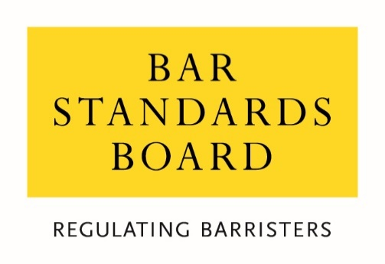

CONSULTATION RESPONSE FORM

Consultation on the future of the Bar Course Aptitude Test (BCAT)

September 2021

Question 1: Do you agree with our analysis of the risks associated with student aptitude and the appropriateness of the BCAT as a regulatory requirement?

Question 2: Is there evidence of other risks we should consider in relation to student aptitude for Bar training as part of our review?

Question 3: Does the BCAT help students make an informed decision on whether to enrol on Bar courses? If you are a current or former Bar student, did the BCAT help you to decide whether to enrol on a Bar training course? Please state how.

Question 4: Which option do you prefer and why?

Question 5: If you prefer option 2, what are the risks that should be addressed and how should the BCAT be amended/replaced to ensure it is addressing the risks identified?

Question 6: Are there any other options we should consider? If so, please state why.

Question 7: In addition to those already stated, does the requirement to take the BCAT before enrolling on a Bar training course have any negative equality impacts on those from disadvantaged or underrepresented groups, or those who are neuro-divergent? If so, please state why.

Question 8: In addition to those already stated, do the proposed policy options have any negative equality impacts on those from disadvantaged or underrepresented groups, or those who are neuro-divergent? If so, please state why.

Question 9: Is there anything else you would like to tell us?

32. Are you a:

- Barrister
- Law Student
- Education and training provider
- Legal consumer / member of the public
- Other legal professional
- Legal services representative body
- Other (please specify)

33. Are you responding in an individual capacity or as a representative of your organisation?

- Individual response
- Organisational response

34. Please give your name or the name of your organisation if you do not wish your response to be anonymous:

Equality Monitoring Information
If you are responding to this consultation as an individual, please complete the following questions:
- What is your age?
- Under 25
- 25-34
- 35-44
- 45-54
- 55-64
- Over 65
- Prefer not to say

- What is your sex?
- Male
- Female
- Prefer not to say

- Is your gender identity the same as the sex with which you were assigned at birth?
- Yes
- No
- Prefer not to say

- What best describes your gender?
- Female
- Male
- Prefer not to say
- I describe myself as:

- Do you consider yourself to have a disability?
- Yes
- No
- Prefer not to say

- Is your ability to perform day-to-day activities limited because of a physical or mental disability, condition or illness, which has lasted or is expected to last for at least 12 months?
- Yes, a lot
- Yes, a little
- Not at all
- Prefer not to say

- What is your ethnic group?
- White – ﻿English/Welsh/Scottish/Northern Irish/﻿British
- White – Irish
- White – Gypsy or Irish Traveller
- White – Roma
- White – I use a different term to describe my White ethnic background
- Asian/Asian British – Bangladeshi
- Asian/Asian British – Chinese
- Asian/Asian British – Indian
- Asian/Asian British – I use a different term to describe my Asian ethnic background
- Black/Black British – African
- Black/Black British – Caribbean
- Black/Black British – I use a different term to describe my Black ethnic background
- Mixed/Multiple Ethnic Background – White and Asian
- Mixed/Multiple Ethnic Background – White and Black African
- Mixed/Multiple Ethnic Background – White and Black Caribbean
- Mixed/Multiple Ethnic Background – White and Chinese
- Multiple Ethnic Background - I use a different term to describe my Mixed/Multiple ethnic background
- Arab
- I use a different term to describe my ethnicity, which does not fall under “White”, “Asian”, “Black” or “Mixed/Multiple Ethnic Background”
- Prefer not to say

- What is your religion or belief?
- No religion
- Buddhist
- Christian
- Hindu
- Jewish
- Muslim
- Sikh
- Prefer not to say
- I have a different religion or belief

- Which of the following best describes your sexual orientation?
- Heterosexual
- Gay or Lesbian
- Bisexual
- Prefer not to say
- I use a different term

- Did you mainly attend a state or fee-paying school between the ages of 11 – 18?
- UK State school
- UK fee-paying school
- School outside UK
- Prefer not to say

- If you finished school after 1980, were you eligible for Free School Meals at any point during your school years?
- Yes
- No
- Not applicable
- Don’t know

- If you went to university (to study a BA, BSc or higher), had either (or both) of your parents or carers attended university by the time you were 18?
- Yes
- No
- Don’t know
- I didn’t attend university
- Prefer not to say

- Are you a primary carer for a child or children under 18?
- Yes
- No
- Prefer not to say

- Do you look after, or give any help or support to family members, friends, neighbours or others because of either: long-term physical or mental ill-health/disability or problems relating to old age? (Do not count anything you do as part of paid employment).
- No
- Yes, 1-19 hours a week
- Yes, 20-49 hours a week
- Yes, 50 or more hours a week
- Prefer not to say

