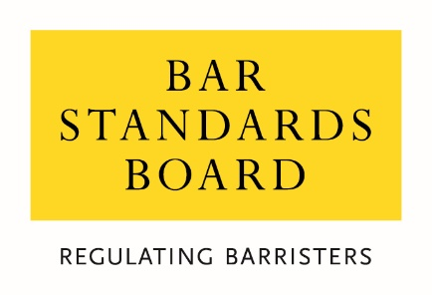

Equality and Diversity Monitoring Form

Name ______________________________________________________________________

Diversity data gathered from this form will be anonymised to assist the BSB in meeting our statutory duties under the Equality Act 2010 and will inform our wider equality and diversity strategy.

Your diversity data will be treated as confidential and stored securely according to the BSB’s Privacy policy. It will not be published in a way which might identify any individual. The raw data will be kept only for monitoring purposes.

Question formats are based on Legal Services Board approved monitoring questions.

Provision of diversity information is not compulsory however we strongly encourage you to help us by completing this form.

Please answer each question in turn by choosing one option only, unless otherwise indicated. If you do not wish to answer the question please choose the option “Prefer not to say” rather than leaving the question blank.

Age

From the list of age bands below, please indicate the category that includes your current age in years:

16 – 24
25 – 34
35 – 44
45 – 54
55 – 64
65+
Prefer not to say

Sex

What is your sex?

Male
Female
Prefer not to say

Gender Reassignment

Is your gender identity the same as the sex that you were assigned at birth?

Yes
No
Prefer not to say

Disability

The Equality Act 2010 generally defines a disabled person as someone who has a mental or physical impairment that has a substantial and long-term adverse effect on the person’s ability to carry out normal day-to-day activities.

(a) Do you consider yourself to have a disability according to the definition in the Equality Act?

Yes
No
Prefer not to say

(b) Are your day-to-day activities limited because of a health problem or disability which has lasted, or is expected to last, at least 12 months?

Yes, limited a lot
Yes, limited a little
No
Prefer not to say

Ethnicity

What is your ethnic group?

Mixed/multiple ethnic groups

White and Asian
White and Black African
White and Black Caribbean
White and Chinese
Any other mixed/multiple ethnic background (write in)

Asian / Asian British

Bangladeshi
Chinese
Indian
Pakistani
Any other Asian background (write in)

Black / African / Caribbean / Black British

African
Caribbean
Any other Black / Caribbean / Black British (write in)

White

British / English / Welsh / Northern Irish / Scottish
Irish
Gypsy or Irish Traveller
Any other White background (write in)

Other ethnic group

Arab
Any other ethnic group (write in)
Prefer not to say

Religion or belief

What is your religion or belief?

No religion or belief
Buddhist
Christian (all denominations)
Hindu
Jewish
Muslim
Sikh
Any other religion (write in)
Prefer not to say

Sexual orientation

What is your sexual orientation?

Bisexual
Gay man
Gay woman / lesbian
Heterosexual / straight
Other
Prefer not to say

Socio-economic background

(a) If you went to University (to study a BA, BSc course or higher), were you part of the first generation of your family to do so?

Yes
No
Did not attend University
Prefer not to say

(b) Did you mainly attend a state or fee paying school between the ages 11 – 18?

UK State School
UK Independent / Fee-paying School
Attended school outside the UK
Prefer not to say

Caring responsibilities

(a) Are you a primary carer for a child or children under 18?

Yes
No
Prefer not to say

(b) Do you look after, or give any help or support to family members, friends, neighbours or others because of either:
– Long-term physical or mental ill-health / disability
– Problems related to old age
(Do not count anything you do as part of your paid employment)

No
Yes, 1 – 19 hours a week
Yes, 20 – 49 hours a week
Yes, 50 or more hours a week
Prefer not to say

Thank you for completing this questionnaire

