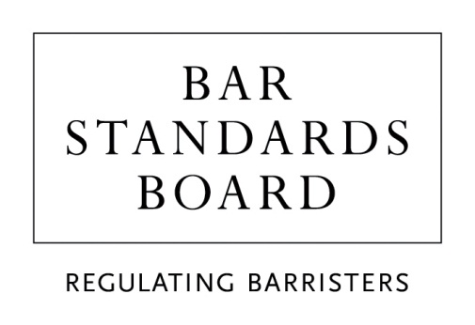

Bar Course Aptitude Test (BCAT)

Reasonable adjustments (accommodations) request form

When completing this form please refer to the BCAT reasonable adjustments (accommodations) policy and procedures.

Do NOT book a BCAT appointment online, this will result in you arriving at the test centre to find you are booked for a standard test with no reasonable adjustments.

Please note ALL fields are mandatory.

Personal details
Candidate BPTC application number (www.barsas.com) | __ __ __ __ __ __ __ __
BCAT ID (www.pearsonvue.com/bsb) | BCAT__ __ __ __ __ __
Name (print in block capitals)
Address for correspondence
Telephone number
Email address
Test centre where you would like to take the BCAT
(Test Centre Search)
Reason for request

Reasonable adjustments (accommodations)
Please tick () and complete as appropriate
Extra time |  | Please select % | 25 / 50 / 75 / 100 %  Other: ______%
(Please note extensions of time are offered in accordance with a candidate’s needs.)
Larger font size |  | Please specify the font size you require | ______ pt
Different colour font |  | Please specify colour
Different colour screen |  | Please specify colour
(Please see the standard font sizes / colours and screen colours all candidates can select before the test, listed in section 4.2 on page 2 of the BCAT reasonable adjustment policy.)
Separate / private room |  | (Not all test centres have a private room.)
Reader (to read items to you)
Recorder (to record your responses on the computer)
Any other reasonable adjustments (Please specify what you require here)

Documentary evidence
Please list and briefly describe the document(s) you are submitting in support of your reasonable adjustments request and the number of documents you have enclosed.
 | List and description of document(s) | Signature
Documents may contain sensitive material, under the Data Protection Act 1998 we are required to obtain your consent for members of BSB staff to view this personal data. Please indicate your consent by signing next to each document listed. Without consent, the documents cannot be accepted as forming part of your request.
Declaration
Candidate Signature
Date
Your reasonable adjustments request form and the accompanying evidence should be submitted to BCAT@barstandardsboard.org.uk

Candidates have the option of completing this form orally over the telephone. Please phone 020 7611 1444 and ask to speak to the BCAT department. Alternatively email BCAT@barstandardsboard.org.uk to request a call back.

For BSB Use Only
Reasonable adjustments request approved | YES / NO
Approved by
Date approved
Date Pearson VUE contacted
Information recorded
Date student informed

