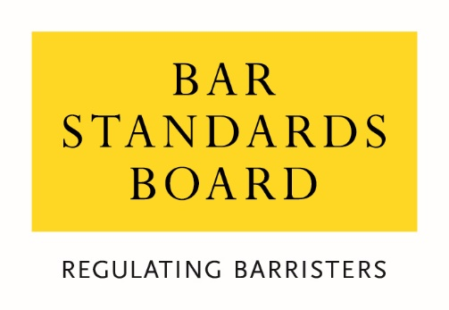
Consultation on proposed amendments to the definition of Academic Legal Training
Consultation Questions
_____________________________________________________________________________________________________
Question 1:
Do you agree with our proposals for changing the definition of academic legal training as described in above in the first key change?

Question 2:
Do you agree with our proposal to remove Part 2 of the Bar Qualification Manual?

Question 3:
Do you agree with our proposal that Authorised Education and Training Organisations make admissions decisions based on the revised definition of academic legal training and in accordance with our guidance?

Question 4:
Do you agree with our proposal to no longer require Certificates of Academic Standing?

Question 5:
Are there any potential equality impacts that you think we have not considered?

Question 6:
If there is anything else you would like to comment on in relation to these proposals, please do so here.

Which of these groups best reflects you:
- Registered Barrister
- An unregistered Barrister who has previously practised
- An unregistered Barrister who has never practised
- Law student
- Education and Training provider
- Legal services consumer / member of the public
- Representative of legal consumers
- Other legal professional
- Legal services representative body
- Other (please specify)

Are you responding in an individual capacity or as a representative of your organisation?
- Individual response
- Organisational response

We will normally publish responses to consultations. If you would prefer to remain anonymous, please tell us.
- I would prefer my response to remain anonymous
- I am happy for my name and/or the name of my organisation to be published
Your Name (if you are happy to be quoted in our consultation response)

The name of your organisation (if you are happy for your organisation to be quoted in our consultation response)

