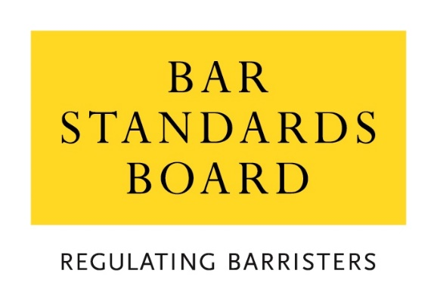

Schedule 4 to the Memorandum of Understanding:
Assurance Framework

April 2023

This Schedule accompanies and sets out arrangements in fulfilment of paragraph 44 of the Memorandum of Understanding (MOU).

Introduction
- This guidance sets out the assurance arrangements in relation to the activities of the Council of the Inns of Court (COIC), the Inns Conduct Committee (ICC) in particular and the Inns within the scope of the MOU. The Parties may review and change the approach taken to assurance from time to time by mutual agreement.
Annual Self-evaluation Report
- Each Inn of Court and the ICC shall develop and share with the Bar Standards Board (BSB) an Annual Self-evaluation Report, covering a period to be agreed between the Parties. This should take the form of a narrative overview of performance against their roles and responsibilities as set out in the MOU. The self-evaluation should have regard to the four principles of Bar Training: flexibility, accessibility, affordability and maintenance of high standards.
- The reports should draw attention to particular challenges and analyse any changes and trends over the period in question, with reference to the implementation of action plans and recommendations from previous evaluations, where relevant. The emphasis should be on analysis rather than description, with reference to supporting data where possible. The Inns and the ICC should also indicate how quality assurance processes have been used to identify and monitor issues of concern, as well as to identify good practice and quality enhancement.
- The self-evaluation will also be informed by risk-based analysis as indicated below. Any actions which are proposed shall be SMART, meaning they are:
Specific – i.e. clear as opposed to vague statements or “ideal scenario” wish lists.
Measurable – it should be clear how it will be known when an action has been completed. Numbers, dates, times and outputs can be used to achieve such clarity.
Achievable – are sufficient resources available to undertake the action?
Realistic – is it feasible in all the circumstances to undertake the action?
Time bound – a clear deadline, by which each action must be completed, should be set.

Complaints analysis
- Annual Self-evaluation Reports shall include the nature and number of formal complaints received relating to the administration of roles and responsibilities set out in the MOU. This should focus on themes, an analysis of trends, lessons learned and improvements made.

External Observers
- External observation reports will be submitted to the Inns on a biennial basis. These reports will form part of the Inns’ Self-Evaluation Reports in the years when external observers are commissioned.

Risk management
- Reports should identify current and future risks to achieving the four principles of Bar Training as relevant to the Inns and the ICC. Reports should also describe mitigating steps taken and planned.

Change management
- Reports should identify changes made during the year and planned for following years, providing information on the context, the reason for the change, the impact and the timescales for implementation.

Fit and proper person checks
- The BSB, Inns and ICC shall agree the personal data to be collected by the Inns and the ICC (as set out at Schedule 3 of the MOU). Aggregated data shall also be produced by the Inns and the ICC. The BSB, Inns and ICC may assess the data in order to promote consistency in decision making and identify improvements.
- Where appropriate, the BSB may review student records to satisfy itself that fit and proper person checks are being conducted correctly against the relevant Guidelines.

Qualifying Sessions
- In accordance with paragraph 39 of the MOU, the Inns assure the BSB and themselves that, subject to exemptions and waivers, students will be required to attend the minimum number of Qualifying Sessions prior to Call.
- Each Inn will provide to the BSB its Qualifying Sessions programme and accompanying Equality Impact Assessment (EIA) for review by the BSB.
- Where appropriate, the BSB may seek further assurances by reviewing a number of anonymised student records to ensure that these individuals have completed the sessions required by the Qualifying Sessions Framework.
- The BSB may review surveys completed by students. The BSB may also review any or all reports from the internal and external observers.
- The BSB may review the outcomes of all quality assurance processes relating to Qualifying Sessions and may attend from time to time for monitoring purposes. At least 24 hours prior notice of attendance will be given.
Recommendations and outcomes
- Following receipt of the Annual Self-evaluation Reports, the BSB may request further assurance that activities comply with any identified requirements and support the achievement of the regulatory objectives and the principles underpinning Bar training.
- Following the review of the Annual Self-evaluation Reports, the BSB may make recommendations to support the Inns and/or COIC (for the ICC) in attaining the objectives and principles set out in paragraphs 2 and 3 of this Schedule.

This may include internal recommendations from an Inn, COIC or the ICC, or recommendations from external auditors or the BSB.
This data will be anonymised.
As set out in the MOU, qualifying sessions framework, decision-making guidelines or any other policies or guidelines.

