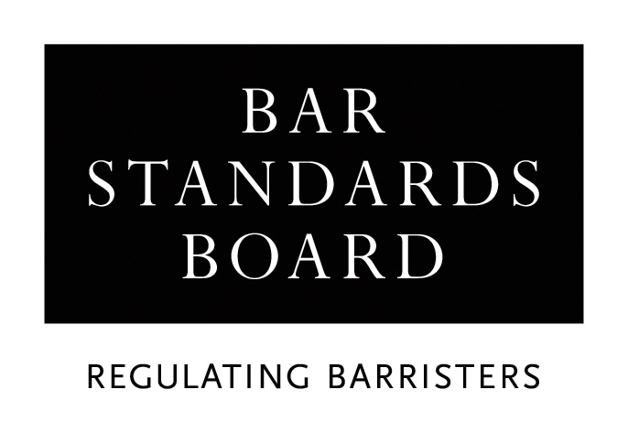

CERTIFICATE OF SATISFACTORY COMPLETION OF PRACTISING PUPILLAGE

PUPIL’S DETAILS
Name of Pupil
Email address
Inn of Court
Date of Call to the Bar
(month/year)

PRACTISING PUPILLAGE (2ND SIX) DETAILS
Name of pupillage provider
(AETO)
Name of Pupil Supervisor(s)
Practising Pupillage dates
(day/month/year - day/month/year)

ADDITIONAL REQUIREMENTS
Pupils’ Advocacy Course date(s)
(day/month/year)
Pupils’ Advocacy Course completed / passed | YES / NO (delete as applicable)
Pupils’ Ethics Assessment date(s)
(day/month/year)
(where applicable )
Pupils’ Ethics Assessment result | COMPETENT / NOT COMPETENT  (delete as applicable)

DECLARATION
- I, the Pupil Supervisor registered with the Bar Standards Board for this pupillage, hereby certify that my pupil has completed a period of practising pupillage satisfactorily between the dates listed above.

- I hereby certify that my pupil has completed the compulsory Pupils’ Advocacy Course and the compulsory Pupil’s Ethics Assessment (where applicable) satisfactorily during this pupillage.

- I have read and discussed the Professional Statement Threshold Standard and Competences with the above-named pupil. I confirm that the pupil has met the requirements specified in the Professional Statement and meets the Threshold Standard.

Pupil Supervisor comments:

Name
Dates during which this person acted as a supervisor for this pupil
Signature
Date of signature

Please return the completed form to:

pupillageadministration@barstandardsboard.org.uk

Please note

- The pupil supervisor at the conclusion of the practising period should complete this form, after consulting with any other supervisors throughout this period of pupillage. If the pupil supervisor is not available to sign this certificate, another person acceptable to the Bar Standards Board (eg Head of Chambers, Director of Pupil Training) may sign it, provided that the certificate confirms who the pupil supervisor was, the dates of supervision and why they have not signed the certificate for the relevant period.

- Where a pupillage has been approved for reduction by the Bar Standards Board, the certificate should be amended accordingly.

GUIDANCE NOTES

Please contact us if further guidance is needed in completing this form.

Meeting your needs

We can provide our literature in different formats, such as Braille, large print, audio tape or compact disc. If you would like this form in a different format, please contact us on 020 7611 1444.

Pupillage providers granted Authorised Education and Training Organisation status by the BSB (AETOs).
Please list all supervisors for this period of pupillage with the dates when they were acting as the supervisor for this pupil
Pupils who commenced training for the Bar from 2020 must complete a BSB exam in Professional Ethics during their pupillage. Transferring Qualified Lawyers (TQLs) may also be required to take this exam under the terms of their BSB authorisation letter. Further information about the new Professional Ethics exam is available on our website - https://www.barstandardsboard.org.uk/training-qualification/becoming-a-barrister/pupillage-component/intro-of-professional-ethics-assessment.html
See https://www.barstandardsboard.org.uk/training-qualification/the-professional-statement.html

