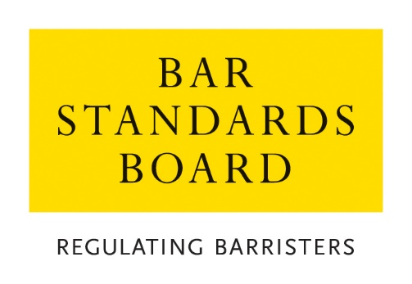

Authorisations Team
Policy on Application Fee Waivers

Contents | Brief Summary
- General  - Fee Waivers  - Exceptional circumstances | This policy sets out our approach to waivers of fee payments in respect of waiver and exemption applications dealt with by the Authorisations Team.  Please consult this policy before contacting the team for further information.  If you have questions which are not covered by this policy, please contact the Authorisations Team via email (authorisations@barstandardboard.org.uk) or via telephone on 020 7611 1444.

- General

1.1 Application fees are payable for most of the waiver and exemption applications processed by the Authorisations Team.

1.2 Application fees cover the processing and assessment cost of an application. Generally, fees are not refundable – please see paragraph 4.3 of our Guidance on Application Fee Payments and Refunds for circumstances in which an application fee payment may be refundable.

1.3 A full list of our applications and the associated fees is available on our website.

- Fee Waivers

2.1 The Overriding Objective: The overriding objective when considering any application for a fee waiver is to ensure fairness.

2.2 Ensuring fairness, includes, so far as is practicable:

- recognising that the general rule is that those seeking a waiver from any rule or requirement should pay the relevant fee and that the granting of a fee waiver is an exceptional course which needs to be justified; and

- considering the circumstances in which the need to make the application for which a fee waiver is sought has arisen, and the extent to which the applicant is responsible for these circumstances; and

- considering the personal and financial circumstances of the applicant.

2.3 An applicant will usually be approved for a fee waiver where they can demonstrate that they are experiencing financial hardship and cannot afford to pay the relevant fee. An applicant must demonstrate that:

- they are in receipt of public funds/benefits; and

- they do not have any other form of income (eg financial support from family members and/or friends); and

- they would have difficulty in meeting their household expenses from their current income if they were required to pay the relevant fee.

2.4 If approved, the relevant application fee will be waived and the substantive application made to the BSB by the applicant will then be processed. The substantive application (eg for admission to the Bar as a Transferring Qualified Lawyer, reduction in pupillage, etc) will not be processed until any related fee waiver has been granted or the fee has been paid in full.

2.5 Applications for a fee waiver must be supported by any particular evidence that we may reasonably require, including the following:

- evidence of UK means-tested benefits (such as Universal Credit, Housing Benefit, Income-based Jobseekers Allowance), or an equivalent overseas benefit. Please note that receipt of UK Child Benefit is not included.

- statements for all bank accounts to which the applicant receives income. These should be from the three months immediately prior to the month of submission of the application.

- Any other evidence of the applicant’s household income and expenditure (eg housing costs, utility costs, etc).

2.6 An applicant must ensure that all supporting evidence is sent with the application, and any failure to do so may result in delays in dealing with the application, or in cases of refusal to provide such evidence, we reserve the right to reject such applications.

2.7 In every case, we may request further information or documentation be supplied in support of an application, but applicants should note that it is their primary responsibility to provide all relevant information and supporting evidence rather than the task of the BSB to ask for it.

- Circumstances (where application fees may not be payable)

3.1 When dealing with the following specific applications, we will also have regard to the following criteria when considering the overriding objective:

- We will usually waive the application fee for any type of application where the applicant provides evidence that the need for the application arose as the result of an administrative or similar error on the part of the Bar Standards Board.

- In the case of applications for Retrospective Registration of Pupillage/work-based learning, we will usually waive the application fee where the applicant supplies confirmation that the pupillage registration was in fact sent to the BSB (by post or email) prior to commencement of the relevant period of pupillage/work-based learning

- In the case of applications for waivers or extensions of time in relation to CPD requirements, we will usually waive the application fee where the waiver or extension of time sought is equivalent to the length of a break in practice on the basis of serious illness, bereavement, maternity/paternity leave, or caring responsibilities for a dependent.

All such applications must be accompanied by
- Evidence of the circumstances leading to the break in practice (eg medical evidence); and
- Confirmation from the applicant’s Head of Chambers or employer (or in the case of an application by a Head of Chambers or a sole practitioner, some other independent confirmation) of the break in practice.

- In the case of applications for extensions of time in relation to CPD requirements, the fact that an applicant has completed his/her requirements very shortly after the deadline will not, in itself, justify a waiver of the application fee.

