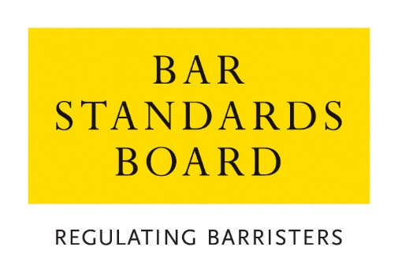

Application for Review by the Bar Standards Board of a decision taken by the Bar Standards Board, an Inn of Court, or The Inns’ Conduct Committee

Rule Q35 of the Bar Standards Board Handbook stipulates that where provision is made under Part 4.B4 of the Handbook for a review by the BSB, any such request for review must be accompanied by:
☐ a copy of any notice of the decision and the reasons for it received by the person requesting the review (ie the applicant); and
☐ any further representations and evidence which the applicant wishes the BSB to take into account;
☐ payment of such fee or fees as may be prescribed.

☐ in the case of a review of a decision of an Inn or the ICC, copies of all documents submitted or received by the applicant which were before the Inn or the ICC.

Please tick the boxes above to confirm that you have provided these with your review request.

PERSONAL DETAILS
Surname:

Other names: | Title:
Correspondence address:

Telephone no.

Email:

DETAILS OF REVIEW REQUESTED
Type of Application:

Date of original decision (ie date of decision letter):

Type of Review sought: (please select)

Full Review – review of all aspects of the original decision
Partial Review – review of one (or more) aspects of the original decision

GROUNDS FOR REVIEW
Ground 1:

Relevant supporting evidence:

Ground 2:

Relevant supporting evidence:

Ground 3:

Relevant supporting evidence:

Ground 4:

Relevant supporting evidence:

Ground 5:

Relevant supporting evidence:

Ground 6:

Relevant supporting evidence:

Continue on a separate sheet, if required

OTHER INFORMATION
Please set out below any further information that you consider to be relevant to your review request:

Continue on a separate sheet, if required

DECLARATION
I confirm that:
- I have read the Criteria and Guidelines;
- The information that I have provided is complete and accurate; and
- Any supporting evidence that I have supplied with this application that refers to third parties has been suitably redacted so as to preserve their anonymity; and
- I have read the Bar Council’s Privacy Statement and understand how my data will be handled.

Signed: | Date:

Please return the completed application form and fee to:

Authorisations@barstandardsboard.org.uk

The fee is non-refundable.

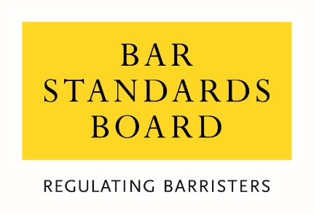

Equality & Diversity Monitoring Form

Diversity data gathered from this form will be anonymised and used to inform Bar Council and Bar Standards Board (BSB) policy aimed at widening access to the profession and improving diversity. It will assist the Bar Council and BSB in meeting our statutory duties under the Equality Act 2010 and will inform our wider equality and diversity strategy.

Your diversity data will be treated as confidential and stored securely according to the Bar Council’s Privacy policy. It will not be published in a way which might identify any individual. The raw data will be kept only for monitoring purposes.

Question formats are based on LSB approved monitoring questions.

Provision of diversity information is not compulsory however we strongly encourage you to help us by completing this form.

Please answer each question in turn by choosing one option only, unless otherwise indicated. If you do not wish to answer the question please choose the option ‘Prefer not to say’ rather than leaving the question blank.

1. Age

From the list of age bands below, please indicate the category that includes your current age in years:

16 - 24
25 - 34
35 - 44
45 - 54
55 - 64
65+
Prefer not to say

2. Gender

What is your gender?

Male
Female
Prefer not to say

3. Disability

The Equality Act 2010 generally defines a disabled person as someone who has a mental or physical impairment that has a substantial and long-term adverse effect on the person’s ability to carry out normal day-to-day activities.

(a) Do you consider yourself to have a disability according to the definition in the
Equality Act?

Yes
No
Prefer not to say

(b) Are your day-to-day activities limited because of a health problem or disability which has lasted, or is expected to last, at least 12 months?

Yes, limited a lot
Yes, limited a little
No
Prefer not to say

4. Ethnic group

What is your ethnic group?

Asian / Asian British

Bangladeshi
Chinese
Indian
Pakistani
Any other Asian background (write in)

Black / African / Caribbean / Black British

African
Caribbean
Any other Black / Caribbean / Black British (write in)

Mixed / multiple ethnic groups

White and Asian
White and Black African
White and Black Caribbean
White and Chinese
Any other Mixed / multiple ethnic background (write in)

White

British / English / Welsh / Northern Irish / Scottish
Irish
Gypsy or Irish Traveller
Any other White background (write in)

Other ethnic group

Arab
Any other ethnic group (write in)

Prefer not to say

Prefer not to say

5. Religion or belief

What is your religion or belief?

No religion or belief
Buddhist
Christian (all denominations)
Hindu
Jewish
Muslim
Sikh
Any other religion (write in)
Prefer not to say

6. Sexual orientation

What is your sexual orientation?

Bisexual
Gay man
Gay woman/lesbian
Heterosexual/straight
Other
Prefer not to say

7. Socio-economic background

(a) If you went to University (to study a BA, BSc course or higher), were you part of the first generation of your family to do so?

Yes
No
Did not attend University
Prefer not to say

(b) Did you mainly attend a state or fee paying school between the ages 11 – 18?

UK State School
UK Independent/Fee-paying School
Attended school outside the UK
Prefer not to say

8. Caring responsibilities

(a) Are you a primary carer for a child or children under 18?

Yes
No
Prefer not to say

(b) Do you look after, or give any help or support to family members, friends, neighbours or others because of either:

- Long-term physical or mental ill-health / disability
- Problems related to old age?

(Do not count anything you do as part of your paid employment)

No
Yes, 1 - 19 hours a week
Yes, 20 - 49 hours a week
Yes, 50 or more hours a week
Prefer not to say

Thank you for completing this questionnaire

Eg terms of waiver/exemption granted, condition(s) set, grounds for refusal of requested waiver/exemption, etc
See https://www.barstandardsboard.org.uk/about-us/how-we-regulate/the-decisions-we-take/authorisations-decisions/reviews-of-authorisations-decisions.html
See https://www.barstandardsboard.org.uk/privacy-statement.html

