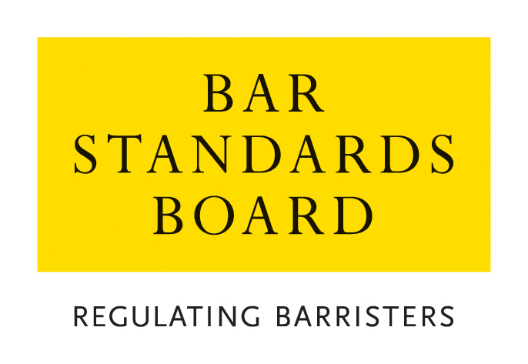

APPLICATION FOR REVIEW OF A DECISION ON ENTITY AUTHORISATION

CRITERIA AND GUIDELINES

- General
  - In these Notes, the Bar Standards Board is referred to as “the BSB”. The BSB Handbook is referred to as “the Handbook”.
  - These Notes set out the criteria and guidelines which the BSB applies in considering applications and should be read carefully and in conjunction with the Handbook.
- Reviews and Appeals
  - Part 3, Section E11 of the Handbook allows you to apply for a review of a decision if you consider that the Bar Standards Board has:
- wrongly refused an application for authorisation or licence; or
- wrongly imposed a term or condition on an authorisation or licence; or
- wrongly modified the terms of your authorisation or licence; or
- wrongly refused to modify the terms of your authorisation or licence; or
- wrongly revoked or suspended your authorisation or licence; or
- wrongly done any of these things in relation to a litigation extension to your authorisation or licence; or
- failed to provide you notice of a decision in accordance with Part 3E; or
- wrongly concluded that either you or somebody else does not meet the suitability criteria either to be designated to act as a “HOLP” or a “HOFA” or to be identified as a non-authorised owner or manager of the applicant body.
  - Any request for a review must be made on the designated application form and accompanied by the relevant application fee within 28 days of notification of the relevant decision. All requests will be acknowledged in writing within seven days of receipt.
  - The Independent Decision-making Body (“IDB”) deals with reviews of decisions as if the application was being dealt with afresh.
  - All review requests are dealt with by an IDB Panel on the documents, only.
  - Applications for review are normally determined within 10 weeks of receipt. Should it not be possible to deal with a review within this timescale, the applicant will be notified.
  - All enquiries about reviews whether proposed or pending should be addressed to the BSB.
  - Rule S121 indicates that a decision of the Bar Standards Board will take effect, notwithstanding the submission of an application for review in accordance with rS118 or rS119. The BSB may, however, in its absolute discretion issue a temporary authorisation, licence or litigation extension to a BSB entity which has lodged an application for review in accordance with Part 3, Section E11.
  - Rule S126 provides that a person or other relevant individual(s) who does not agree with the decision taken by an IDB Panel on a review request may appeal to the First Tier Tribunal against the decision. In accordance with Rule S126A, any appeal to the First Tier Tribunal must be lodged within 28 days of notification of the IDB Panel’s decision.
- How applications are dealt with
  - Applications must be made on the current designated application form, available from the BSB’s website, and accompanied by the application fee.
  - Please return the completed application form with accompanying documentation and payment of the application fee to authorisations@barstandardsboard.org.uk. If you are unable to submit your application by email, please contact us for further guidance.
  - Applicants who may have particular difficulties in following the standard application procedure or need reasonable adjustments related to a disability may contact the BSB to discuss how these needs can be met.
  - All applications contain a declaration that the applicant has read, understood and complied with these Criteria and Guidelines.
  - The declaration must be completed with a hand-written signature. If you have no access to scan and print the application form - please write out the declaration from the application form by hand, sign it, take a photo of the document and email that to us as evidence of your handwritten signature.
  - An applicant must ensure that all supporting evidence is sent with the application form. We will accept copies of academic transcripts or professional confirmations emailed directly from the awarding body/regulator. If you are unable to provide documents by this method, please submit scans of your personal copies. We may contact the awarding body/regulator of any scanned documents provided directly by you to verify their content.
  - An application will not be treated as “complete” until the application form, required supporting documentation and application fee have been received. The BSB may request further information or documentation be supplied in support of an application, but applicants should note that it is the primary responsibility of the applicant to provide all relevant information and supporting evidence.
- Applicants should exercise judgement when selecting supporting evidence and ensure that only documentation relevant to the criteria set out in this document is supplied.
- It is usually not appropriate to supply examples of work with an application. Any applicant who does supply such examples should ensure that documents that refer to third parties (eg clients) are suitably redacted so as to ensure anonymity. Any application that is supported by unredacted material will be returned to the applicant.
  - The BSB will take into account all the circumstances of the particular application and will apply the guidelines set out in these Notes.
  - The BSB will treat all applications and any supporting documentation provided in the strictest confidence.
  - All enquiries about applications whether proposed or pending should be addressed to the BSB.
- Application Fees
  - The application fees for each type of review application and methods of payment are listed on the BSB website. The preferred method of payment is bank transfer (BACS). Once your application has been logged by the Authorisations Team, an invoice will be generated and sent to you by email to enable you to make a BACS payment. You must quote the invoice reference when making a payment by BACS.
  - If you are unable to pay by BACS, you may make payment by credit/debit card. Once you have received an email acknowledgement that your application has been logged, please call the Authorisations Team on 020 7611 1444 to make a card payment.
  - Details of our Fee Waiver policy are available on the BSB website.

Online Resources
BSB website: www.barstandardsboard.org.uk
Applications forms and guidance notes: https://www.barstandardsboard.org.uk/about-us/how-we-regulate/the-decisions-we-take/authorisations-decisions/reviews-of-authorisations-decisions.html

Authorisation Team Service Update Page: www.barstandardsboard.org.uk/about-us/how-we-regulate/the-decisions-we-take/authorisations-decisions/authorisations-team-service-update.html

For further information, please contact the Authorisations Team on authorisations@barstandardsboard.org.uk or 020 7611 1444

