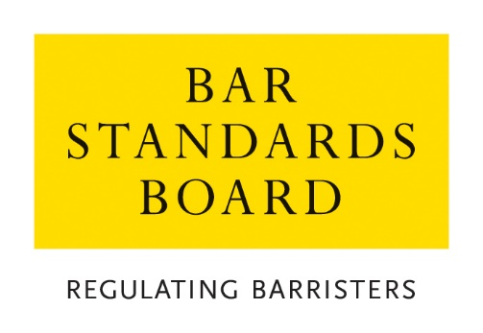

Authorisations Team
Guidance on Application Fee Payments and Refunds

Contents | Brief Summary
- General  - Methods of payment  - Payment via instalment plans  - Refunds | This document sets out our approach to fee payment in respect of waiver and exemption applications dealt with by the Authorisations Team.  Please consult this document before contacting the team for further information.  If you have questions which are not covered by this document, please contact the Authorisations Team via email (authorisations@barstandardboard.org.uk) or via telephone on 020 7611 1444.

- General

  - Application fees are payable for most of the waiver and exemption applications processed by the Authorisations Team.

  - Application fees cover the processing and assessment cost of an application. Generally, fees are not refundable – please see paragraph 4.3 below for circumstances in which an application fee payment may be refundable.

  - A full list of our applications and the associated fees is available on our website.

- Methods of Payment

  - Once you have submitted your application form (via email or the MyBar portal), we will generate an invoice for the fee and send it to you, by email. When paying an application fee, you will need to quote your Invoice ID to enable us to reconcile your payment.

  - Our preferred method of payment is bank transfer (BACS). When paying by BACS, you must ensure that the BSB receives the full amount in Sterling: ie you must pay all charges of your bank and agents charges, including those of the BSB. This may include a handling charge levied by RBS if the issuing bank does not pay all bank charges.

  - Applicants making payment via BACS are responsible for ensuring that the correct bank details are used, and the correct amount is transferred.

  - International banking charges: You must pay any international banking charges in addition to the prescribed fee (your bank should be able to advise you on this). We will not process applications where less than the prescribed fee is received. Please see information regarding international refunds in the Refunds section of these guidelines.

  - If you are unable to pay by BACS, you may make payment by credit/debit card. Once you have received an email acknowledgement that your application has been logged and you have received your invoice by email, please call the Authorisations Team on 020 7611 1444 to make a card payment.

  - If you are making payment via telephone, please ensure that you are using your own credit/debit card. If a third party will be making a payment with their own credit/debit card on your behalf, please ensure that they are able to quote your full name, your postal and email addresses, and your invoice reference.

  - Please note that we do not accept cheques or cash in payment of application fees.

  - You must submit your application (ie your completed application form and all related supporting documents) before you pay the prescribed fee. If you choose to make an advance fee payment and do not submit the related application form and supporting evidence within one month of the date of your payment, any funds transferred to us will be written off by our Finance Department. In these circumstances, funds will be subject to our accounting reconciliation process and will not be recoverable by you for future applications or available for either a full or partial refund.

- Instalments Plans

  - The Authorisations Team no longer offers payment by instalment plan for application fees. If an applicant is unable to afford the cost of an application, they should refer to the information regarding fee waivers, as set out in the team’s Fee Waiver Policy (available on the Bar Standards Board website).

- Refunds

  - Please see the following information on how refunds are issued:

    - If you have overpaid the application fee, we will contact you directly to arrange a refund. Alternatively, if you think you are entitled to a refund (in line with paragraph 5.3 below) you may contact the Authorisations Team directly.

    - The Authorisations Team is not obliged to refund fees paid where no related application form is submitted.

    - We require the following details from you in order to process a refund:
- Applicant name
- Applicant’s home address (if it is outside of the UK)
- Bank name
- Bank account holder name
- Sort code
- Account number

    - When submitting a request for a refund you must provide us with the bank details used to make the original payment. You should ensure that the bank details and payment reference match exactly otherwise the automated payment system will reject the payment.

    - You should allow 15 working days for us to process your refund request.

    - International refunds: Please be advised that we do not cover the cost of international banking and we will recover the cost of any international banking charges from your refund. If the international banking charges are expected or likely to exceed the refundable amount, a refund will not be processed.

  - Refunds will not be issued in the following circumstances:

- Where the applicant pays the application fee but does not submit the application form within one month of payment.

- Where assessment of the application has commenced.

- Where a decision for an application has been issued.

  - Refunds may be issued in the following circumstances:

- Full refund: Where assessment of the application has not yet commenced, and the applicant informs us that they do not wish to continue with the application.

- Full refund: Where the applicant receives a successful fee waiver decision and has already paid the application fee.

- Partial refund: Where the applicant has overpaid their application fee (please note restrictions on this rule specified in paragraph 4.1)

- Partial refund: Where the applicant has submitted payment of an incorrect fee amount (eg by paying the fee associated with a different application type from the application form that they completed). It may be appropriate to refund part of the original payment if the correct fee is lower than the amount paid. If the original payment is lower than the correct fee, then it may be possible to transfer that payment to the correct fee and for the applicant to pay the balance. Applicants in such circumstances should contact the Authorisations Team directly to discuss the appropriate course of action.

